## CHAPTER 1

**ABOUT THE COMPANY**

* 1. **ABOUT TECHNOMIND IT SOLUTIONS (TMITS)**



     TMITS initially was an Idea. In the year 2013 with the efforts of the four friends lead to a real time entity forming a firm with goal to develop Business oriented software’s and train students in the global market, providing solutions in the field of business through websites, creating innovations through mobile applications.

A Group of enthusiastic members led to the startup of Technomind IT Solutions (TMITS).

Friends at Engineering College with the identical goal, to change the world with Innovation

* **Corporate Address:**

“Vetoba Prasanna” building Savgoan Road Nanawadi

Belgaum-590009 Karnataka,India

***http://www.boredbees.com/images/mail.png***info@tmits.in

***http://www.boredbees.com/images/phone.png***919036067944, 91831 0445698

* **Technominds IT Solution Overview**

Website: www.tmits.in

Headquarters: Belagavi

Size: 8 Employees.

Founded: 2015

Type: Company - Private

Industry: Information Technology

Revenue: 10 Lakh to 25 Lakh (INR) per year

* **MISSION**

Young brains leading to the formation of Firm under the name Technomind IT Solutions. The mission of Technomind IT Solutions is to continue to provide flexible and easily understandable business solutions, while optimizing advances in technology, thus continuously providing business a spirited edge.

* **VISION**

Technomind IT Solutions is established, with the objective of providing quality software products and services in various fields by harnessing the power of information technology

**1.2 SERVICES AND PRODUCTS OFFERED BY THE COMPANY**



Enterprise software applications have been the cornerstone of business proliferation of computers, increasing their footprint into different business processes, workflows, regulatory frameworks and business intelligence for all commercial enterprises, governments as well as non-profit organizations. Technomind IT Solutions teams have analyzed, designed, developed, implemented, tested, maintained, migrated and supported various enterprise applications.

**1.2.1 Web Development**

One thing that makes business grow across the globe is a website. We develop websites that helps you grow your business in all the quadrilaterals. We are having a highly experienced team that develops websites of great look and feel and of high performance and quality. We develop both static and dynamic websites suitable for small, medium and large scale enterprises. We develop websites for enhanced user experience, simplicity flexibility and versatility. It allows you to enter data in a variety of ways, without any restrictive formats, thus making work a pleasure.

* Web Designing
* Static Website Designing
* [Website Design for Professional](http://www.boredbees.com/webdesign.php)
* Website for Small Business
* [Website for Large Business](http://www.boredbees.com/large.php)
* [Flash Website Design](http://www.boredbees.com/flashdesign.php)
* [Flash Intro Design](http://www.boredbees.com/intro.php)
* [Flash Animation](http://www.boredbees.com/flashanimation.php)
* Flash Banner Design
* [Web Redesign](http://www.boredbees.com/redesign.php)
* Web development
* Web application.
* Customize CMS
* Html 5
* SEO

**1.2.2 Mobile App Development**

We also develop mobile applications that keep our Customer connected to your business any time anywhere. Mobile apps help you to remain connected to your business even when you are out of office. We develop mobile applications according to client requirements. We develop customized mobile application that helps make work a pleasure. We develop mobile application on ANDROID platform which can be installed on almost all smart phones. We develop mobile applications for all professionals that help them to grow in their fields.

**1.2.3 Desktop Applications**

TMITS focuses on developing high quality, reliable, and cost effective desktop applications that address all business requirements and evolving needs. We develop applications that help you to automate your business thus keeping the data intact and secured. We develop desktop applications for Hospitals, educational institutes, Industries, Banking domain, Hotels, resorts, etc.

We develop both stand alone and client server applications according to the client’s requirements that helps the client to keep track of the accounts, manage leads, sales order management, stock management, Keeps track of employees, helps in performance of employees , helps to maintain a healthy relation with the customers.

**1.2.4 Testing Services**

We undertake testing of websites, desktop applications, mobile applications, web applications. We test the applications on almost all standards that help to deliver a bug free application to the client. We see to it that when we deliver the application to the client it is almost bug free so that the client gets full benefits of the application and don’t waste time in resolving errors of the application.

**1.2.5 Training to the Trainers**

Real time training is the key to success. Today corporate are looking out for technically skilled students in almost all domains. We train students on open source technologies that help them to compete with the external world. We also provide training on real time applications. We provide training on the following:

* Java
* HTML/CSS
* PHP
* Software Testing / Manual / Automation
* Android Application Development
* Real Time Application Development / Testing

**CHAPTER 2**

**ABOUT THE DEPARTMENT**

The Managing Director of the organization manages the various departments like management as well as technical. The company includes various departments working simultaneously.

**2.1 The Production Department**

The Production department undertakes the activities necessary to provide the organization’s products or services. Its main responsibilities are Production planning and scheduling, Control and supervision of the production workforce, Managing product quality (including process control and monitoring, Maintenance of plant and equipment, Control Of Inventory, Deciding the Best Production Methods and Factory Layout.)

**2.2 The Marketing Department**

Marketing is concerned with identifying and satisfying customer needs at the right price. Marketing involves researching what customers want and analyzing how the organization can satisfy these Wants. Marketing activities range from the ‘strategic’, concerned with the choice of product markets (and how to compete in them, for example, on price or product differentiation) to the operational, arranging sales promotions, producing literature such as product catalogues and brochures, placing advertisements in the appropriate media and so on.

A fundamental activity in marketing is managing the marketing mix consisting of the ‘4P’: Product, price, promotion, and place.

* **Product:** Having the right product in terms of benefits that customers value.
* **Price:** Setting the right price which is consistent with potential customers’ perception of the value offered by the product.
* **Promotion:** Promoting the product in a way which creates maximum customer awareness and persuades potential customers to make the decision to purchase the product.
* **Place:** Making the product available in the right place at the right time –including choosing appropriate distribution channels.

**2.3 The Human Resources**

The Human Resources department is concerned with Recruitment and selection where it ensures that the right people are recruited to the right jobs, Training and development where it enables employees to carry out their responsibilities effectively and make use of their potential, Employee relations including negotiations over pay and conditions, Dealing with complaints from employees or from the employer, Health and Safety by making sure employees work in a healthy and safe environment, Redundancy procedures by administering a proper system that is seen to be fair to all concerned when deciding on redundancies and agreeing redundancy payments.

**2.4 The Product Development**

As intern in the company I started working in the product development department. Product development is the process of designing, creating and marketing new products or services to benefit customers, Sometimes referred to as new product development, the discipline is focused on developing systematic methods for guiding all the process involved in getting a new product to market. Product development involves either improving an existing product or its presentation, or developing a new product to target a particular market segment or segments. Consistent product development is a necessity for companies striving to keep up with changes and trends in the marketplace to ensure their future profitability and success. A competitive product development strategy should include a company-wide commitment to creating items that fulfill particular consumer needs or characteristics.

These characteristics might include consumers’ desire for the following: products that are high-quality or low-cost; products that provide the consumer with speed or flexibility; or products that offer some other form of differentiation that posits them a desirable purchase.

**2.4.1 The functions performed by product department**

* Testing
* Identifying new product candidates
* Gathering the voice of customers
* Defining product requirements
* Determining business-case and feasibility
* Scoping and defining new products at high level
* Building product road-maps, particularly technology road-maps
* Developing all products on schedule, working to a critical path
* Ensuring products are within optimal price margins and up to specifications
* Ensuring products are manufacturable, and optimizing cost of components and procedures.

**2.4.2 Roles and Responsibilities in Department**

* **Do Early Homework:** Every employee is responsible for understanding the work allotted and determining if it is appropriate for him. He/she should make sure whether he/she has mastered the skills required to perform the task completely.
* **Plan with the Manager:** Having a proper work schedule or time table for the work allotted to the employee helps the employee in Time Management and reaching the deadlines in time Also, when a new work is allotted.
* **Participation:** Active listening and participation in teams will ensure that all employees become good team players and work with unity towards common goals of the Organization. Whenever a new work is being allotted all the Employees should be eager enough to take the initiative rather than trying to avoid newer tasks. This will facilitate in employees learning new skills and reaching the Organizational goals with much effectiveness.
* **Cleanliness is Next To Godliness:** One should maintain the cleanliness of their desk, and also premises of the Organization. If you and your premises are clean you will find it more encouraging to work and also it is convenient to work for other employees.

**CHAPTER 3**

**INTERNSHIP OBJECTIVES**

Internship experience plays a vital role for every student to implement their theoretical knowledge and get a practical knowledge from any organization. A student can implement this internship experience in his future work area. To know about the problems faced in the software industry.

The objectives of working as an intern are:

* To know how the technical problems are solved.
* To know the coding pattern and conventions of the industry.
* To go through the development cycle and models.
* Working with documentation and customization.
* Understanding the importance of software maintenance.
* To learn the workflow of the industries.
* Gain better knowledge and understanding in the field which we work.

This report has covered the direct and indirect aspects of software industry and its challenges. The report gives an insight of the experience that I achieved from my workplace. A brief description of “Technomind IT Solutions” is included so that other students can get to know about the company and may decide whether it is suitable for them or not. Internships are about gathering skills and projects are the best way of implementing the skills learnt.

**CHAPTER 4**

**ACTIVITIES PERFORMED**

Development of Online Matrimonial Site. Online Matrimonial Site is a web based application. Matrimonial sites are popular in India as an alternative to the traditional marriage broker. Online Matrimonial site register users, after which they are able to upload their profile onto a searchable database maintained by the website. Those users looking to find suitors search the through this website with customized searches that typically include nationality, age, gender, availability of photograph and often religion, geographic location ,caste and so on.

**DATA FLOW DIAGRAM (DFD):**

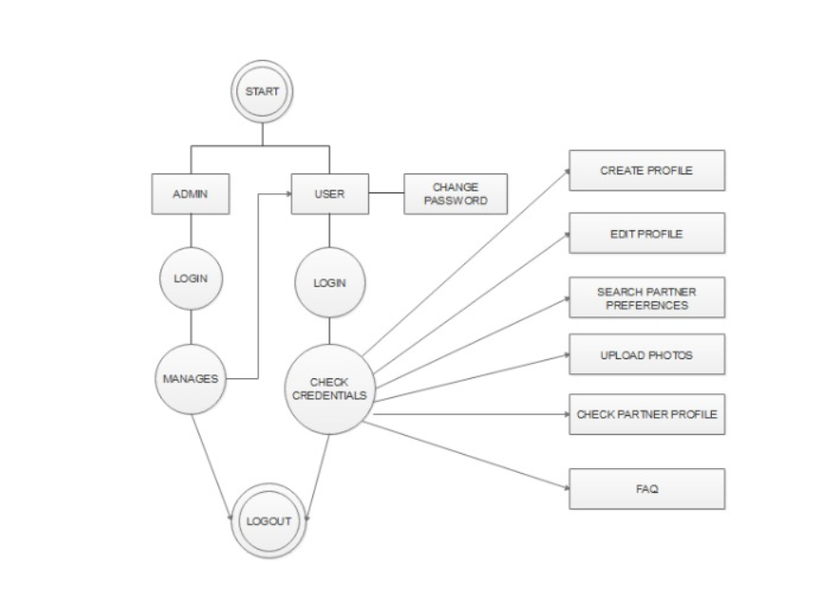

**ER DIAGRAM:**

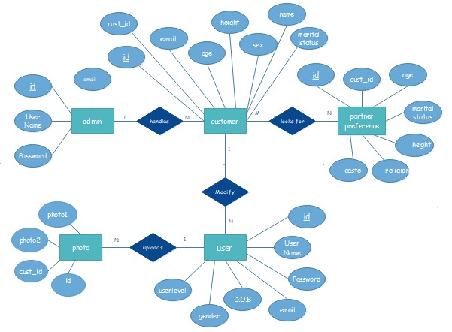

* 1. **Functionality of Website:**

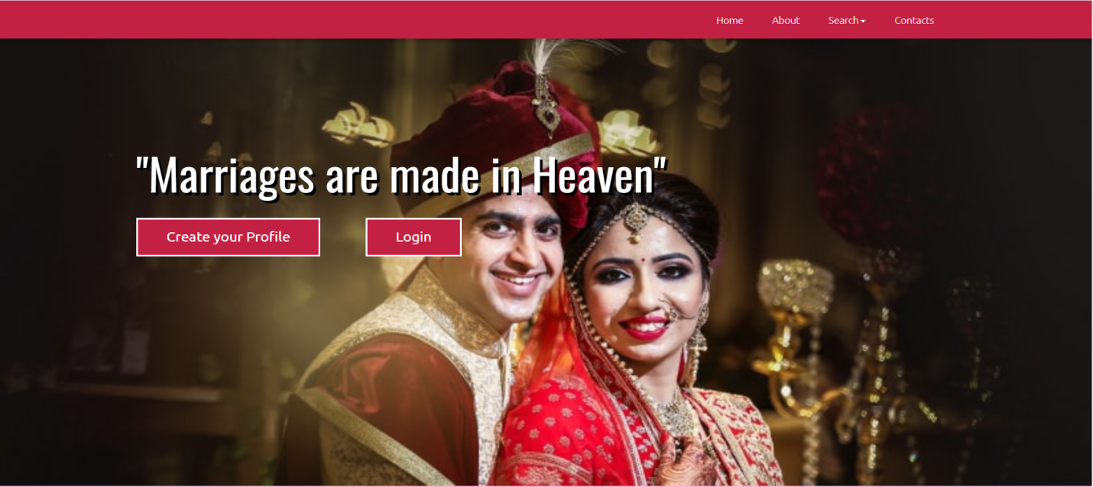

**Fig 1: Home Page of the Website**

* Initially the customer needs to create his profile i.e that is he/she needs to register to this website by entering the required details.
* If the Customer has already created the account ,he can directly login to his/her profile by

entering respective username and password provided during registering to the website.

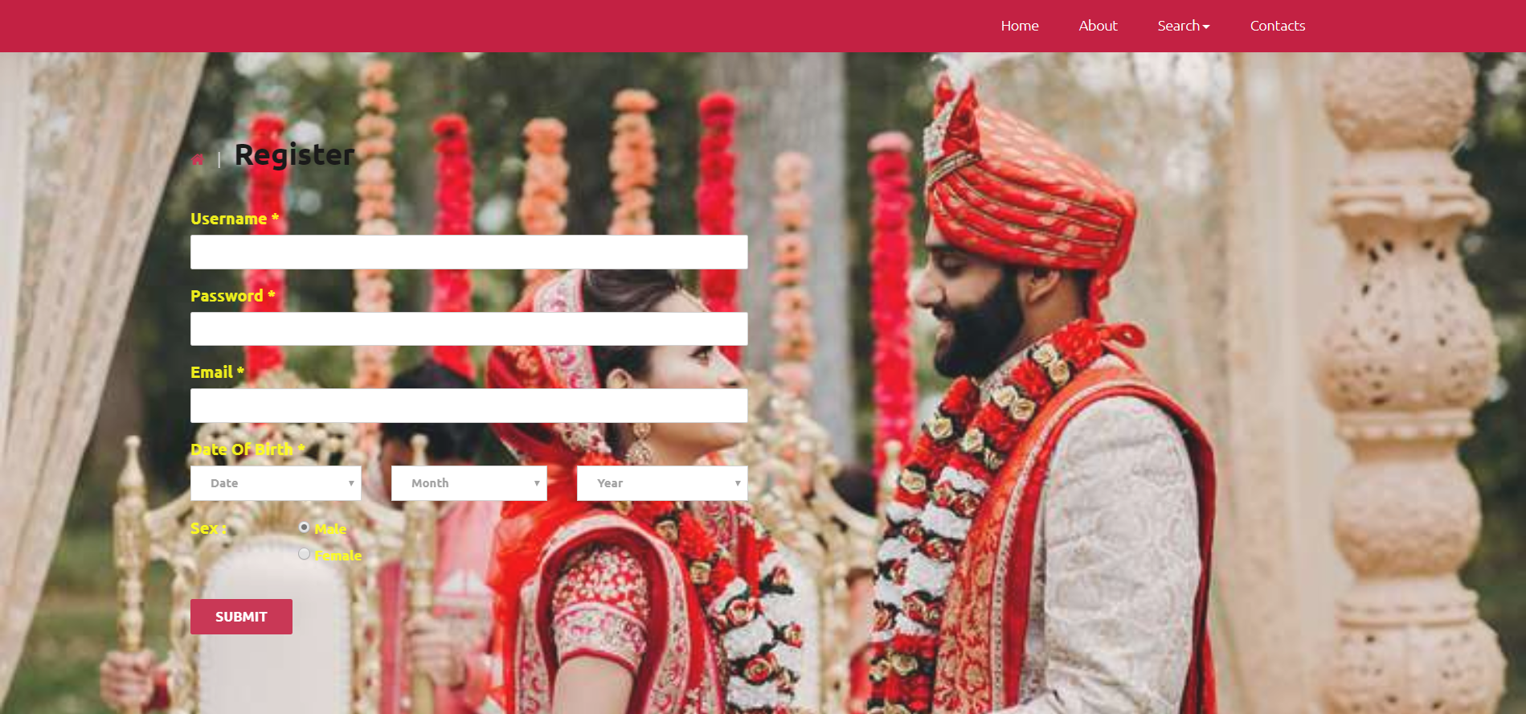

**Fig 2: Register Page of the Website**

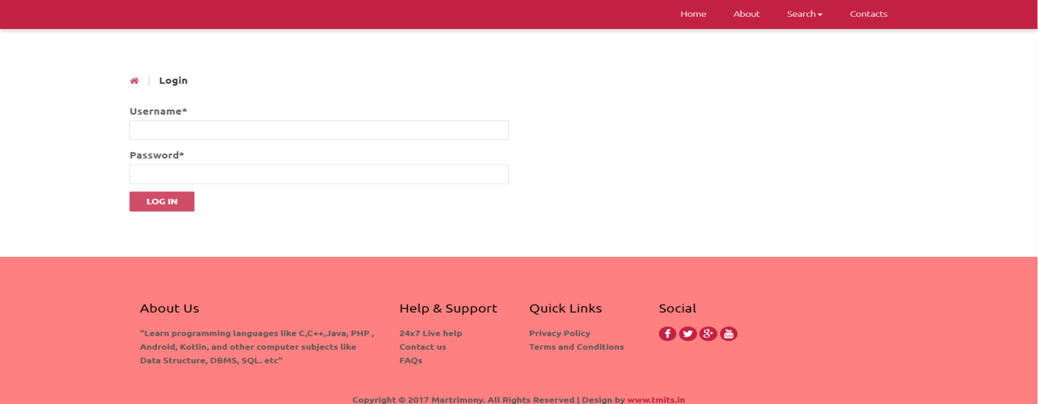

**Fig 3: Login Page of the Website**

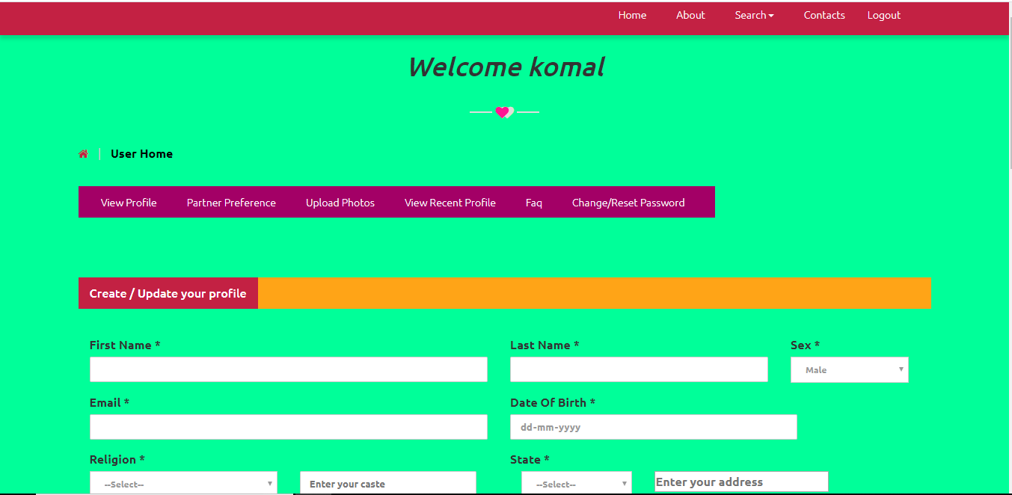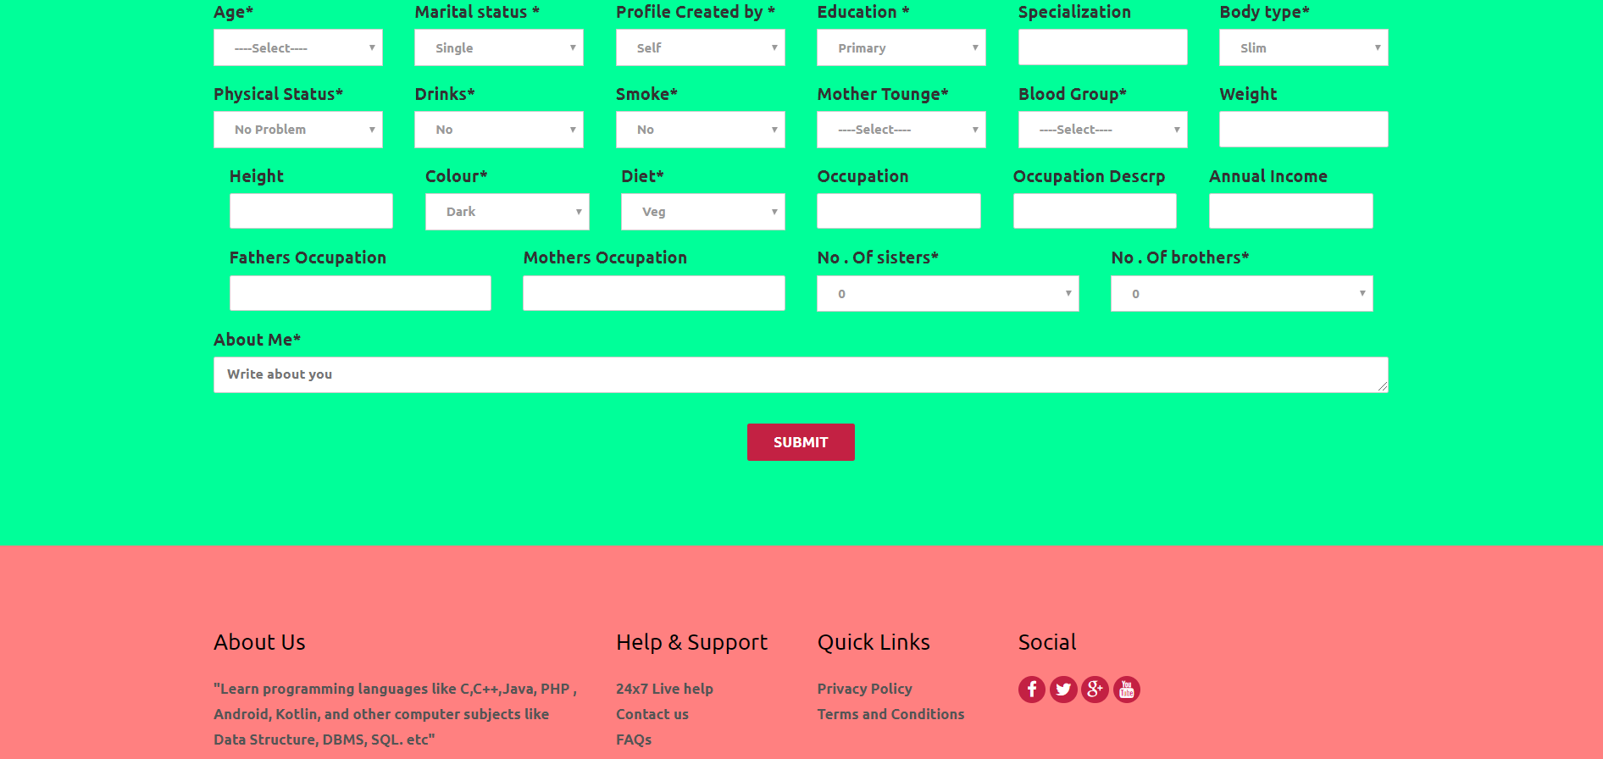

**Fig 4: User Home Page**

* After Customer logs –in to the website ,they will be directed to user home page where user can utilize the various functionalities provided by the website such as ,
* Creating and Updating his profile by submitting his necessary details as name, sex, gender, dob, religion, caste, age, education, parents details and so on.
* The customer can view their profile created.
* Customer can set their partner preferences.
* Customer needs to upload their two photos.
* Customers can view recent profiles.
* Customer can Change or rest his/her password.
* Customer can view faq to clarify their doubts.

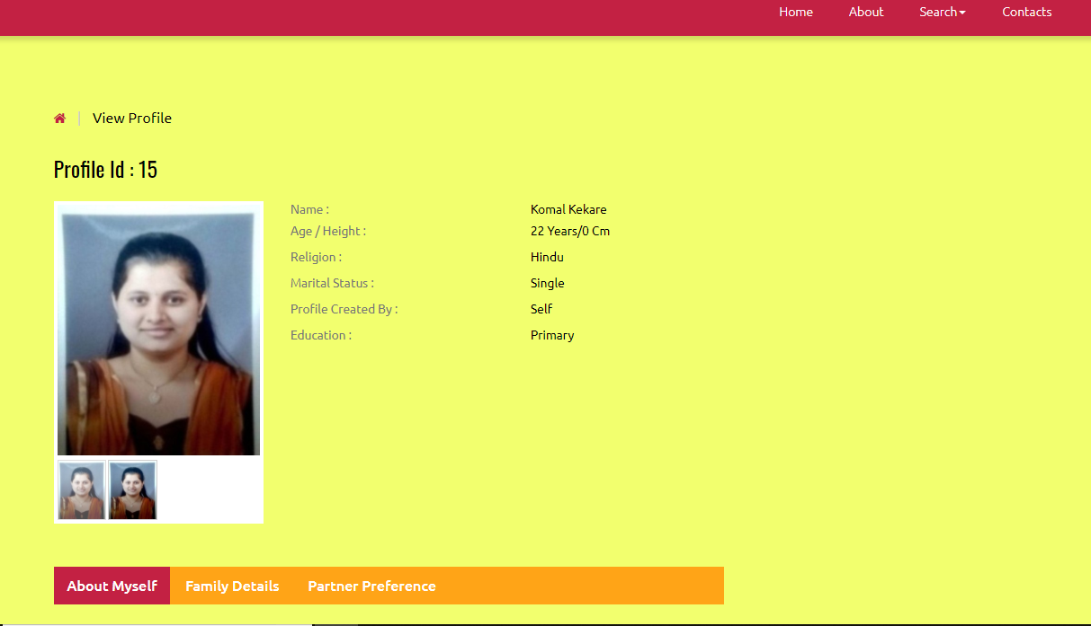

**Fig 5: View Profile Page**

* Through this page the candidate can view their profile uploaded which consists of all the details uploaded such as about myself, family details, partner preferences and so on.

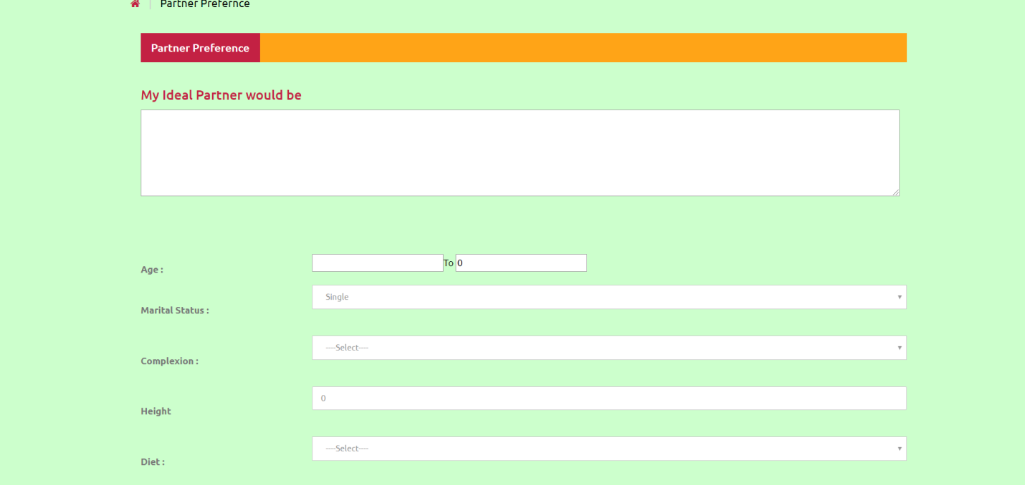

**Fig 6: Partner Preferences Page**

* Customer can set or update his/her partner preferences via this page , so that the other candidate viewing the profile can get to what are the preferences of his/her partner.

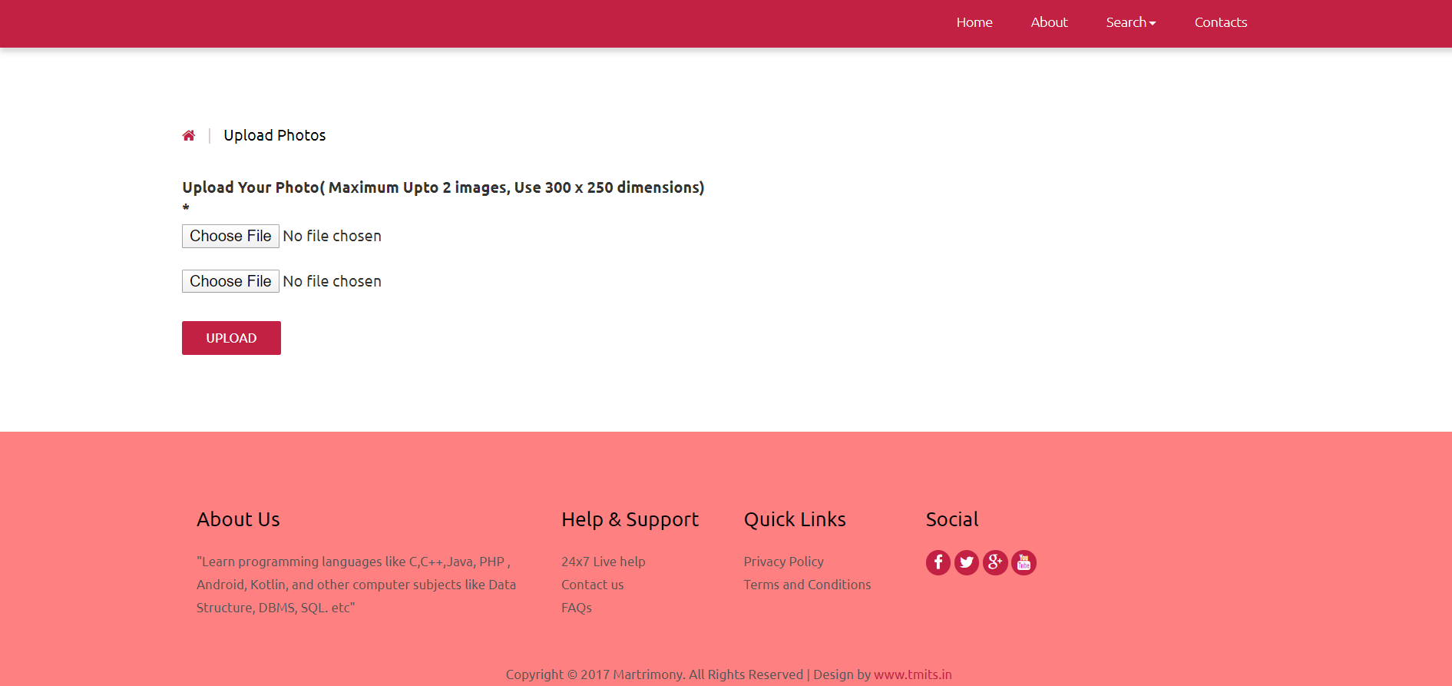

**Fig 7: Photo Upload Page**

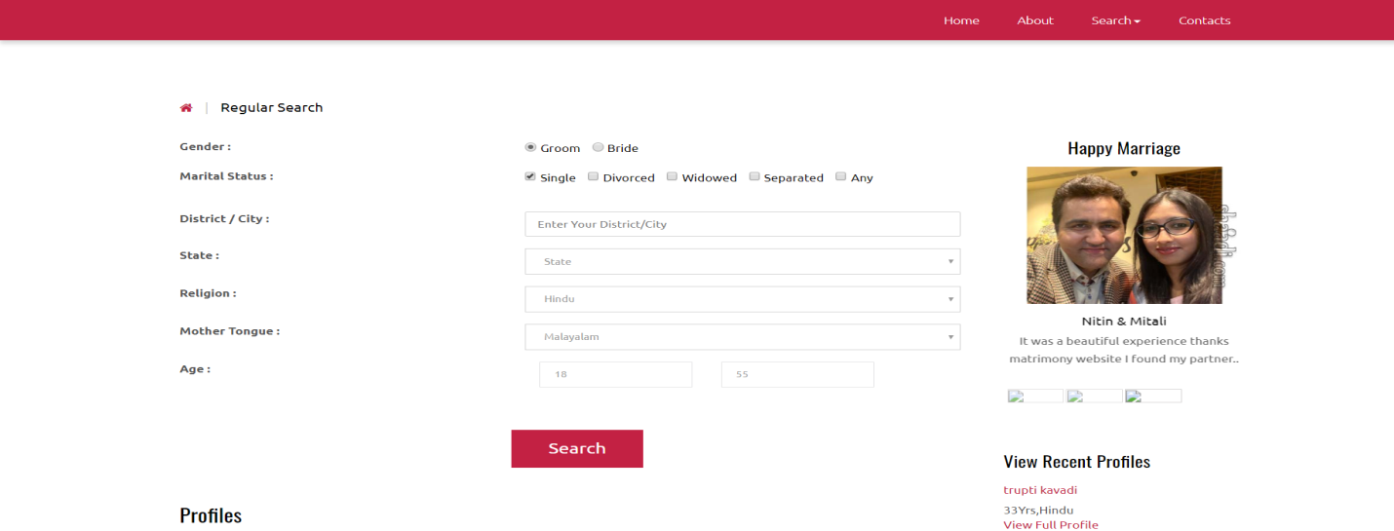

**Fig 8: Regular Search Page**

* By selecting the Regular Search option available on the header part of the page the customer can search candidate registered on this website by entering details required details based on requirements and click on search button.
* On clicking on search button the website will match the details provided by the candidate with the available database and will display the matching profile to the customer.

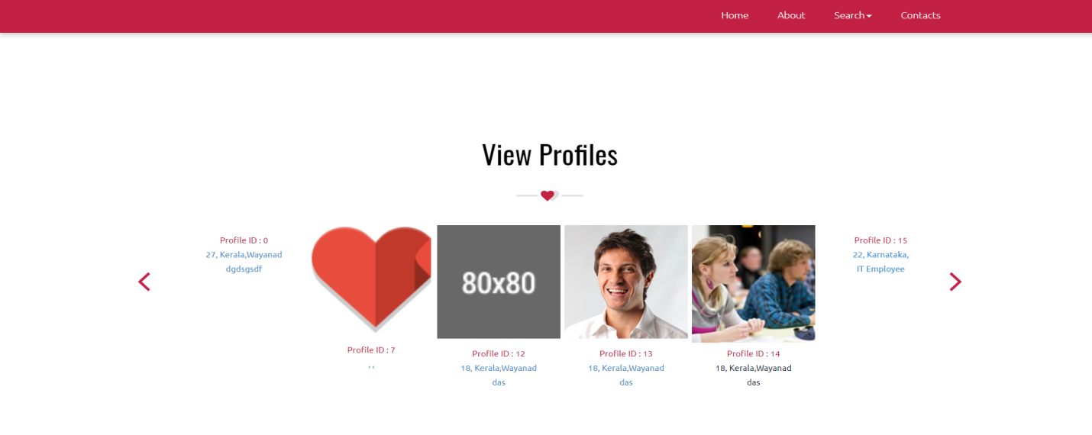

**Fig 9: Search Existing Profiles Page**

* This page will allow the customers to view existing profiles of all customers registered on this website.

**4.2 TECHNICAL TOOLS LEARNT**

**4.2.1 HTML**

First developed by Tim Berners-Lee in 1990, **HTML** is short for **HyperText Markup Language**. HTML is used to create electronic documents (called pages) that are displayed on the World Wide Web. Each page contains a series of connections to other pages called hyperlinks. HTML code ensures the proper formatting of text and images so that your Internet browser may display them as they are intended to look. Without HTML, a browser would not know how to display text as elements or load images or other elements. HTML also provides a basic structure of the page, upon which Cascading Style Sheets are overlaid to change its appearance.

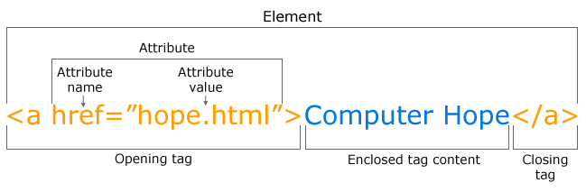

As seen above in the above example of an HTML tag there are not many components. Almost all HTML tags have an opening tag that contains the name with any attributes and a close tag that contains a forward slash and the name of the tag that is being closed. For tags that do not have a closing tag like the <img> tag, it is best practice to end the tag with a forward slash.

Each tag is contained within a less than and greater than angle brackets and everything between the opening and closing tag is displayed or affected by the tag.

In the above example the <a> tag is creating a link called "Computer Hope" that is pointing to the hope.html file.

The following is an example of a basic web page written in HTML as well as a description of each section and its function.

<!DOCType HTML PUBLIC "-//W3C//DTD HTML 4.01 Transitional//EN" "http://www.w3.org/TR/html4/loose.dtd">  
<html lang="en"><head>  
<title>Example page</title>  
<meta http-equiv="Content-Type" content="text/html; charset=windows-1252">  
</head>  
<body>  
<h1>This is a heading</h1>  
<p>This is an example of a basic HTML page.</p>  
</body></html>

The box above contains the key ingredients to a basic web page. The first line (DOCType) describes what version of HTML the page was written in so that an Internet browser can interpret the text that follows. Next, the HTML opening tag lets the browser know that it is reading HTML code. The HTML tag is followed by the headsection which contains information about the page such as its title, meta tags, and where to locate the CSS file. The body section is all content that is viewable on the browser. For example, all the text you see here is contained within the body tags. Finally, closing tags wrap each element for proper syntax.

**HTML5**  is the update made to HTML from HTML4 (XHTML follows a different version numbering scheme). It uses the same basic rules as HTML4, but adds some new tags and attributes which allow for better semantics and for dynamic elements that are activated using javascript

As shown below the HTML5 code is very similiar to the earlier HTML4 example, but is much cleaner with the revised doctype tag.

<!doctype html>  
<html>  
<head>  
<meta charset="utf-8">  
<title>Example page</title>  
</head>  
<body>  
<h1>This is a heading</h1>  
<p>This is an example of a basic HTML page.</p>  
</body>  
</html>

* **Advantages**
* Easy to use.
* Loose syntax (although being too flexible will not comply with standards)
* Supported on almost every browser, if not all browsers.
* Widely used; established on almost every website, if not all websites.
* Very similar to XML syntax, which is increasingly used for data storage.
* Free – you need not buy any software.
* Easy to learn and code even for novice programmers.
* **Disadvantages**
* It cannot produce dynamic output alone, since it is a static language
* Sometimes, the structuring of HTML documents is hard to grasp
* You have to keep up with deprecated tags, and make sure not to use them
* Deprecated tags appear because another language that works with HTML has replaced the original work of the tag; thus the other language needs to be learned (most of the time, it is CSS)
* Security features offered by HTML are limited

**4.2.2 OVERVIEW CSS**

**C**ascading **S**tyle **S**heets, fondly referred to as CSS, is a simple design language intended to simplify the process of making web pages presentable.

CSS was invited by **HåkonWium Lie** on October 10, 1994 and maintained through a group of people within the W3C called the CSS Working Group. The CSS Working Group creates documents called specifications. When a specification has been discussed and officially ratified by W3C members, it becomes a recommendation.

CSS handles the look and feel part of a web page. Using CSS, you can control the color of the text, the style of fonts, the spacing between paragraphs, how columns are sized and laid out, what background images or colors are used, layout designs, variations in display for different devices and screen sizes as well as a variety of other effects.

**Advantages of CSS**

* **CSS saves time** − You can write CSS once and then reuse same sheet in multiple HTML pages.
* **Pages load faster** − If you are using CSS, you do not need to write HTML tag attributes every time. Just write one CSS rule of a tag and apply it to all the occurrences of that tag. So less code means faster download times.
* **Easy maintenance** − To make a global change, simply change the style, and all elements in all the web pages will be updated automatically.
* **Superior styles to HTML** − CSS has a much wider array of attributes than HTML, so you can give a far better look to your HTML page in comparison to HTML attributes.
* **Multiple Device Compatibility** − Style sheets allow content to be optimized for more than one type of device. By using the same HTML document, different versions of a website can be presented for handheld devices such as PDAs and cell phones or for printing.
* **Global web standards** − Now HTML attributes are being deprecated and it is being recommended to use CSS. So its a good idea to start using CSS in all the HTML pages to make them compatible to future browsers.
* **Offline Browsing** − CSS can store web applications locally with the help of an offline cache. using of this, we can view offline websites. The cache also ensures faster loading and better overall performance of the website.
* **Platform Independence** − The Script offer consistent platform independence and can support latest browsers as well.

**Three Ways to Insert CSS**

There are three ways of inserting a style sheet: External style sheet, Internal style sheet, Inline style.

* **External Style Sheet**

An external style sheet is ideal when the style is applied to many pages. With an external style sheet, you can change the look of an entire Web site by changing one file. Each page must link to the style sheet using the tag. The tag goes inside the head section:

<head>

<link rel=”stylesheet” type=”text/css” href=”mystyle.css”/>

</head>

* **Internal Style Sheet**

An internal style sheet should be used when a single document has a unique style. You define internal styles in the head section of an HTML page, by using the

<head>

<style type=”text/css”>

p {margin-left:20px;}

</style>

</head>

* **Inline Styles**

An inline style loses many of the advantages of style sheets by mixing content with presentation. Use this method sparingly! To use inline styles you use the style attribute in the relevant tag. The style attribute can contain any CSS property. The example shows how to change the color and the left margin of a paragraph:

<p style=”color: sienna”>This is a paragraph.</p>

**4.2.3 PHP**

PHP is a server-side scripting language designed for web development but also used as a general-purpose programming language.Originally created by RasmusLerdorf in 1994, the reference implementation of PHP (powered by the Zend Engine) is now produced by The PHP Group. While PHP originally stood for *Personal Home Page*, it now stands for *PHP:* Hypertext Preprocessor, which is a recursive acronym.

PHP code can be simply mixed with HTML code. PHP code is usually processed by a PHP interpreter, which is usually implemented as a web server's native module or a Common Gateway Interface (CGI) executable. After the PHP code is interpreted and executed, the web server sends the resulting output to its client, usually in the form of a part of the generated web page; for example, PHP code can generate a web page's HTML code, an image, or some other data.

The PHP interpreter only executes PHP code within its delimiters. Anything outside its delimiters is not processed by PHP (although non-PHP text is still subject to control structures described in PHP code). The most common delimiters are <?php to open and ?> to close PHP sections. The purpose of all these delimiters is to separate PHP code from non-PHP code, including HTML.

* **PHP offers plenty of possibilities:**
* PHP is appropriate whenever you want your pages to be created dynamically when the browser requests the page
* PHP makes it easy to customize a Web page to make it more useful for individual users.
* With PHP you can set cookies, manage authentication, and redirect users.
* One of PHP most powerful features is database access. With PHP it is possible to access over 19 different types of databases and manipulate data within those databases based on input from the user via a web page.
* PHP makes it easy to send e-mail, work with newsgroups, and actually open a connection to another web site -- and get or send data with it.
* **Disadvantages**
* Security : Since it is open sourced, so all people can see the source code, if there are bugs in the source code, it can be used by people to explore the weakness of PHP.
* Not suitable for large applications: Hard to maintain since it is not very modular.
* Weak type: Implicit conversion may surprise unwary programmers and lead to unexpected bugs. For example, the strings "1000" and "1e3" compare equal because they are implicitly cast to floating point numbers.

**4.2.4 BOOTSTRAP**

Bootstrap is a sleek, intuitive, and powerful, mobile first front-end framework for faster and easier web development. It uses HTML, CSS, and Javascript. Bootstrap was developed by Mark Otto and Jacob Thornton at Twitter. It was released as an open source product in August 2011 on GitHub.

**Why Use Bootstrap?**

•**Mobile first approach:** Bootstrap 3 framework consists of Mobile first styles throughout the entire library instead of them in separate files.

•**Browser Support:** It is supported by all popular browsers.

•**Easy to get started:** With just the knowledge of HTML and CSS anyone can get started with Bootstrap. Also the Bootstrap official site has a good documentation.

•**Responsive design:** Bootstrap's responsive CSS adjusts to Desktops, Tablets and Mobiles. More about the responsive design is in the chapter Bootstrap Responsive Design.

• Provides a clean and uniform solution for building an interface for developers.

• It contains beautiful and functional built-in components which are easy to customize.

• It also provides web-based customization. And best of all it is an open source.

**4.2.5 XAMPP**

XAMPP stands for Cross-Platform (X), Apache (A), MySQL (M), PHP (P) and Perl (P). It is a simple, lightweight Apache distribution that makes it extremely easy for developers to create a local web server for testing purposes. Everything you need to set up a web server – server application (Apache), database (MySQL), and scripting language (PHP) – is included in a simple extractable file. XAMPP is also cross-platform, which means it works equally well on Linux, Mac and Windows.

**CHAPTER 5**

**REFLECTION NOTES**

By doing internship at Technomind IT Solutions helped me develop and learn lots of things. The good thing is that they not only gave us technical information but also gave us some insights of some apps and software like Trello, Publisher MS-office , Designing websites using templates and Adobe Photoshop and so on. I learned how to come up with strategies. The knowledge that I have gasined from my education has really helped me in this area.

The past months of my internship have been very instructive for me. Technomind IT Solutions has offered me opportunities to learn and develop myself in many areas. Technically I have learnt a lot, especially in the field of designing Web Pages. We started with preparing Data Flow Diagram (DFD) for the project assigned to us . Then started implementing our project according to the instructions given to us.

I have learned to work in team and apply my knowledge into practice. I learned a lot from the different interns that I have been working with during my internship. Each intern had their own suggestions and ideas that made it interesting for me.

My mentor during my internship was Bhushan Sir from whom I have also learned a lot during my internship. As an Entrepreneur, he as lots of knowledge in industry. He was very helpful and always willing to give me advice and feedback which I appreciate. He was the one who give us idea and we have to implement it in practice. They believe in brainstorming and coming up with our own ideas and views. Hence I could learn how I can put my knowledge into practice. I have tried to learn as much as possible from him and the interns during my internship.

Overall, my work experience at Technomind IT Solutions was positive. I was very happy with the amount of things that I have learned and experienced in the 4 weeks of being an Intern with the company. I believe that Vishveshwaraya University should keep this aspect of the Engineering course as it does provide students with the experience needed in order to find a job later on. Also, it can be very beneficial as it could lead to a more permanent position.

**CHAPTER 6**

**CONCLUSION**

I am glad that I was a part of such great organization. Working as an Intern at Technomind IT Solutions helped me develop and learn lots of things. The knowledge that I have gained from my education has really helped me in this area.

The current work is the initial background report for the website development project. This report aims to provide a critical review of the relevant literature in the web field and also to describe key aspects of the methodology that will be applied throughout the project. It helped me to understand the use of HTML, CSS AND PHP. I also learnt how a software engineer has to work. This report tries to examine various issues that arise while building a website. It is important to highlight, that websites are not simple software artifacts. Mastering the necessary software skills and tools to build a website does not guarantee its success. For this reason, following the guidance and the advice of my supervising professor, this report focuses on many other challenges that come up through the development process, like performing website evaluation, conducting market research and choosing the right business model for the website proposal. These are the first and most crucial steps that will ensure that the final IT employment website will be developed according to the requirements of the market and will be tailored to the needs of its users. Further research and more focus will be given on software tools after these parts of the methodology are complete and will be presented in later stages of the project. It helped to enhance and develop my skills, abilities, knowledge and confidence to deal with the IT world. It was a good experience and collection of memories, not only have I gained experience, but also new friends and contacts. Technomind IT Solutions is a good place to do internship since it provide numerous benefits to practical trainees. I am grateful and thankful to Bhushan Sir for giving guidelines and for being so supportive.

**CHAPTER 7**

**REFERENCES**

1. <https://www.w3schools.com/html/> - Syntax for various HTML tags.
2. <https://www.w3schools.com/php/> -Syntax and functions of php.
3. <https://www.w3schools.com/colors/colors_picker.asp>-Colors codes to make the page attractive.
4. <https://www.sourcecodester.com/tutorials/php/9692/index.php>- Reference to implement change password
5. <https://www.shaadi.com/services/explore>/-To refer what all are the features to be added to our website.